Discussion of the sonic_correction function in

OTM-33A

Tara Yacovitch, tyacovitch@aerodyne.com

The sonic_correction function aims to rotate a 3D wind into a 2D plane, and then center that 2D vector in the 180 degree direction.

Multiple times, a rotation angle is computed using the formula

$$A=180+atan2\left(-y,-x\right)*180/π$$

I believe the formula should be:

$$A=180-atan2\left(y,x\right)*180/π$$

Reasoning:

In the mathematical convention (degrees counter-clockwise from the x axis), an arbitrary vector (x,y)’s angle from the x axis is:

$$A_{math}=atan2\left(y,x\right)*180/π$$

The rotation angle required, in mathematical convention, to rotate the vector (x,y) to the –y axis is –90 degrees. This is the rotation angle we want for the OTM-33A method.

$$A_{math}=atan2\left(y,x\right)*180/π-90$$

Converting to the compass convention (degrees clockwise from North):

$$A_{comp}={90- A}_{math}=90-atan2\left(y,x\right)*180/π+90=180+atan2\left(y,x\right)*180/π$$

Effect:

Both methods of calculating angles result in the same x, y and z rotated wind vectors for the STR_3061611_01.xls test file. In the following graph, data produced by python code is indicated by “py_” while data from the origin code (using the corrected equations) is shown in thin pale overlay.



The difference comes with the final assignment of the corrected wind direction. In the graph below, the source data is shown in black, while the rotated data is overlaid. Green traces are data from the Python/Matlab method. Red data are from the Igor Pro version of the software, with the corrected equation. Note that the red data has already been masked for wind direction.



The goal of the sonic correction is to rotate coordinates into a streamlined set of coordinates at a direction of 180 degrees. The python/matlab code (green) is not doing this correctly.

Correcting this single line of code in the python program brings the methods into exact agreement for the Gaussian fit of binned data (left = Origin, right = Python). Differences in the calculation of source emission is currently under investigation.

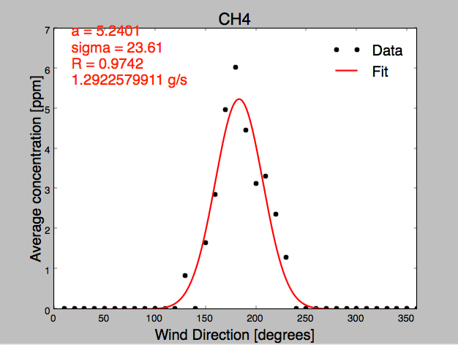

on the use of atan:

I also note that using atan instead of atan2 in certain areas of the code is overly restrictive, and causes errors for winds from the north. For Aerodyne’s mobile lab data, which is corrected for vehicle bearing, plumes are frequently measured with averaged wind directions in the northern quadrant; atan2 is required.